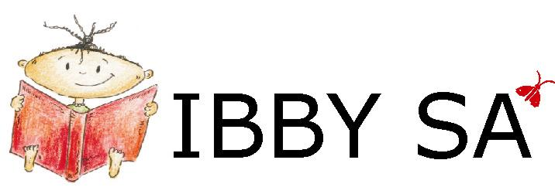
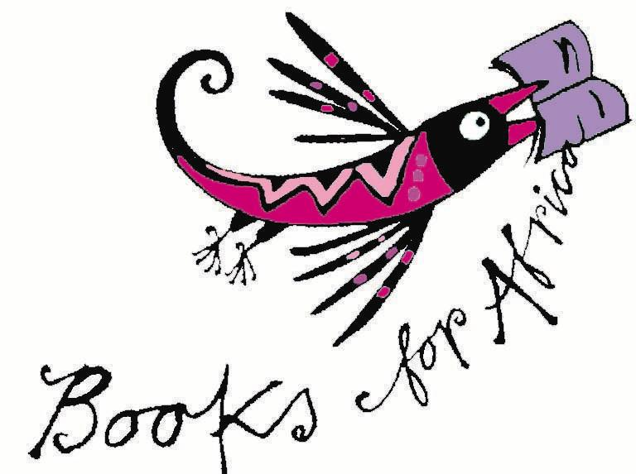
NEWSLETTER No. 47
February 2008

IBBY SA Box 847 Howard Place 7450 South Africa
email info@ibbysa.org.za
Books for Africa newsletter email booksforafrica@iafrica.com
website www.ibbysa.org.za
- IBBY SA is the South African section of IBBY.
- IBBY is the International Board on Books for Young People.
- IBBY SA’s area of interest is everything to do with South African books for children and young people.

- If you are a member of IBBY SA, you are also a member of IBBY.
- IBBY’s 2004 World Congress was hosted by IBBY SA in Cape Town.
- Its next World Congress will be in Copenhagen, Denmark, in 2008

O amohelehile! Re tshepa hore o tla thabela ho bala pampitshana ena e fupereng tse thahasellisang le tse susumetsang.
Index:
Featured Reviews WriterProfile VinnigVra Kompetisie Important Dates in big IBBY’s IBBY SA Events Calendar
Katrine Harris Award Revived Resensies Membership Fees End

Featured Reviews

Back to Index

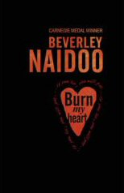
This month our regular reviewer of English books Vinesh Rajpaul reviews two books for teenagers. They are both set in Kenya in the 1950s. One is written by Beverley Naidoo, IBBY SA’s nominee for the Hans Christian Andersen Award; and the other is written by distinguished Kenyan author Meja Mwangi. After the two reviews, Vinesh offers a comparative note.

Beverley Naidoo: Burn my Heart (Penguin Books South Africa, Johannesburg, 2007)


Kenya, 1951. The dawn of the bloody Mau Mau Rebellion, during which more than 12 000 native Kenyans would be killed, and 150 000 imprisoned, in the fight for their independence from Britain. Only 32 European settlers would be killed. This is the setting for Carnegie-medallist Beverley Naidoo’s new novel, Burn My Heart.

Matthew is the eleven-year-old son of Jack Grayson, a white farm-owner; Mugo is thirteen years old and the son of one of Jack Grayson’s labourers. Matthew and Mugo have been bosom friends for many years; however, the Mau Mau Rebellion will soon change their lives and friendship irrevocably.

Although Burn My Heart considers some of the horrific aspects of war and
colonialism, the focus of the book is the effect these things have on the boys’
lives, and young readers will easily relate to their struggles. This is a beautifully crafted tale of friendship and betrayal: thought-provoking, bold and compellingly realistic.

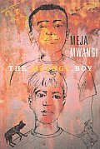
Meja Mwangi: The Mzungu Boy (Groundwood Books / House of Anansi Press, Toronto, 2005)

The Mzungu Boy is set in Kenya during the early 1950s: the time of the Mau Mau Rebellion, when native Kenyans revolted against the oppressive and exploitative rule of colonial Britain. Twelve-year-old Kariuki’s life is filled with hardship: early in the story his entire village is imprisoned and interrogated by Bwana (Master) Ruin, the ruthless and powerful local landowner. Kariuki’s father is believed to be connected to the Mau Mau; his father’s life is spared, but only because he is Bwana Ruin’s cook. Having survived the imprisonment, Kariuki is beaten by his headmaster for having been absent from school. However, Kariuki is able to find solace in the beautiful forests, rivers and grassy plateaus around his village. It is in these places that Kariuki goes hunting with his new friend Nigel: a white British boy who has come to the village to spend the holidays with his grandfather, Bwana Ruin.

Against their families’ wishes Nigel and Kariuki develop a staunch friendship, but soon they get caught up in the sinister and dangerous world of the rebellion. When Nigel is captured by Mau Mau soldiers, it’s Kariuki who tries to save him.
The Mzungu Boy is a riveting story that offers young readers an introduction to African colonial history; moreover, this is an honest and touching tale of friendship. The Mzungu Boy won the prestigious Deutscher Jugend-literaturpreis (1992) and the Children’s Africana Book Award (2006).

Burn My Heart vs The Mzungu Boy

The two books are similar in many respects (1950s’ Kenya; the Mau Mau Rebellion; a fictional account of the friendship between two young boys – one black, one white). However, The Mzungu Boy is aimed at slightly younger readers (9–12-year-olds, or thereabouts) whereas Burn My Heart will appeal to slightly older readers (perhaps the 11–14-year-old age-group). Accordingly, The Mzungu Boy focuses more firmly on the friendship between the protagonists, only touching briefly on some of the dark aspects of war and colonialism; Burn My Heart considers more boldly the emotional and physical devastation caused during the Rebellion.

Both books are written by inter-nationally acclaimed and award-winning authors and, not surprisingly, it would be difficult to choose between the two. Either book will offer young readers an accessible and memorable tale of friendship, and insights relevant to any human conflict, not just the Mau Mau Rebellion.

Why choose, though? Get both!

– Vinesh Rajpaul

***
A Note to Publishers: If you would like to have your latest books reviewed in Books for Africa, please send review copies Attention: Robin Malan to the IBBY SA postal address (at the head of this newsletter) or have them delivered to IBBY SA at Huis der Nederlanden 4 Central Square Pinelands.

WriterProfile
Back to Index

Dianne Case is the winner, with Yvonne Hart, of the English category in the 2007 Maskew Miller Longman Literature Award, with the teen novel Katy of Sky Road.

We asked her a few questions about herself, and these are her answers:

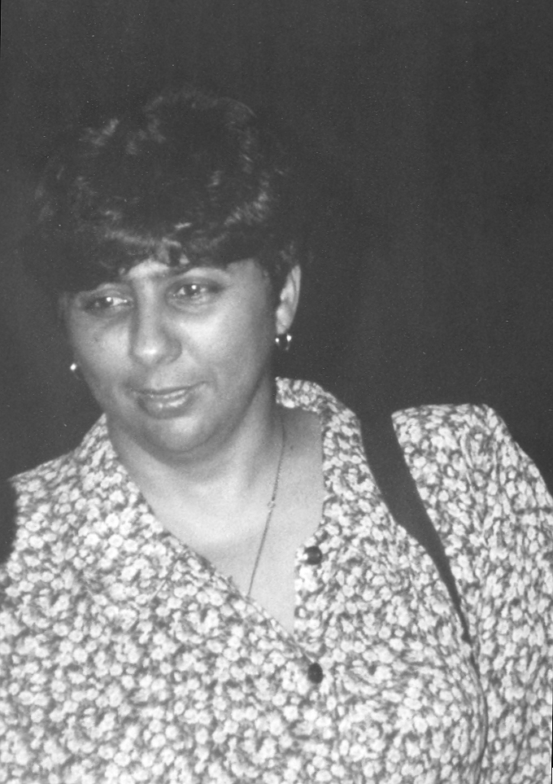
1) You’re used to winning awards, but what was it like winning this one?
When I was younger I used to enjoy the attention very much, but this particular one was different, because I shared it with Yvonne Hart. Katy of Sky Road comes from a movie we wrote together while partnered on the Sediba scriptwriting programme. Best of all was to see the very lively characters find their way into print.

2) When did you start writing, and how did it come about?
I have always enjoyed writing, since a child, but started writing seriously when my father died suddenly at the age of 58. I was 23 then and struggled to accept it. I wondered how other people coped; after all, people die all the time, yet life goes on. So I wrote Albatross Winter, in which someone else could deal with death and make sense of it for me.

3) Other than your own, of course, do you have a favourite South African book for children or young people? Tell us about it.
There are very many. Top of my list is The Gift of Gold by Dorothy Kowen, which has such a strong message of love for children of all ages. An old favourite is Some of us are Leopards, some of us are Lions by Mike Kantey, a wonderful book about difference and acceptance of self, lovely pictures, also for all ages. Wart, a fun book by my daughter Bonita, is wonderful for early teenagers. For older, more serious children there is All We Have Left Unsaid by my daughter Maxine, which won the 2007 Commonwealth Writers’ Prize (Africa region) Best First Book, as well as being the joint winner of the Herman Charles Bosman Prize.

4) Two of your daughters are published writers. Tell us about them.
I have three daughters, all very different, all living in different cities, all of whom write. Bonita, the eldest, lives in London and had Wart published when she was very young, well before she did her Master’s degree at UCT. She is married and has a young daughter. Maxine is my middle child and lives in Cape Town and works in marketing for NB Publishers. Lizanne is an economist and lives in Johannesburg. She works as a business analyst for FNB, and writes pages and pages on world economics, emerging markets and developing economies. My daughters are all comfortable with words, having grown up reading and journaling.

5) You also have your own publishing house. Fill us in on that a bit.
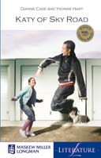
I started Kwagga at a time that there was a crisis in publishing in the country. I had written a children’s book on Madiba and was clear about what I wanted, but no local publisher had the budget for it at the time, so I thought I would do it myself. It was a learning experience and we had a measure of success. We also published in collaboration with authors, where we shared expenses and profits, which was also successful. We have received much attention, locally and abroad, such as launching a book in French at the Salon du Livre in Paris. However, having learnt from the experience, I am now doing co-publication deals where I can tap into an established infrastructure. Currently, What a Gentleman (the book on Madiba) is being translated into all 11 languages and is being co-published with Maskew Miller Longman. I believe we can and do produce books that stand up to the best in the world.

VinnigVra Kompetisie / QuickQuiz Competition
Back to Index

Last time we clearly overtaxed your poor overworked brains after you’d had such an overwrought, busy, hard-working year! Nobody, but nobody, even entered the competition! Let alone won it! What a shame, because we had such a nice prize all lined up. Can’t carry it over, I’m afraid, because we popped it and drank it ourselves! So there.

Anyway, here’sh all the anshwers. It was all about Numbers. We said: See how many number-answers you can give for these nine questions. Now we add the answers in red:
- Darrel Bristow-Bovey’s heroic effort at a teenage novel. SuperZero
- Hoeveelkantkind? Eenkantkind deur Marita van der Vyfer
- How many round moons and a star for me? One Round Moon and a Star for Me by Ingrid Mennen, illustrated by Niki Daly
- How many friends were there in Jacana’s taxi? Three Friends in a Taxi by Maryanne Bester, illustrated by Shayle Bester
- The howmanyth man was found floating in OUP’s school swimming pool? The Eighth Man by Michael Williams
- How many books are there in the Jacana series Exploring Our Provinces? Nine. Duh.
- Which house-number in Dianne Case’s Queen’s Road? 92 Queen’s Road
- How many books do we say there are in IBBY SA’s list of Representative South African Books for Children and Young People? 100. Nog ’n Duh.
- Which flat-number in Mogamat I Davids’s Colleen Court? 111 Colleen Court

We will ease you into this year’s competitions with a dead-easy question:

Bahlodi ba Hans Christian Andersen Award ba tla ba neng le ho kae?
When and where will the winners of the 2008 Hans Christian Andersen Awards be announced?
Waar en wanneer word die wenners van die Hans Christian Andersen-prys aangekondig?
Abantu abaphumelele iiMbasa zikaHans Christian Andersen baza kupapashwa nini, phi?

Romela dikarabo tsa hao ho:
Send your answers to:
Stuur jou antwoord aan:
Thumela iimpendulo zakho ku:

booksforafrica@iafrica.com

Mpho ya buka e ka'nna ya ba ya hao.
A prize of a book may come your way.
Dalk is daar ’n boek op pad.
Kungenzeka ubenethamsanqa lokuphumelela isipho sencwadi.

Important Dates in Big-IBBY’s 2008
Back to Index

Watch out for 31 March 2008 at the Bologna Children’s Book Fair. That’s the day when the two winners of the 2008 Hans Christian Andersen Award are announced.

IBBY SA has nominated:

- Beverley Naidoo in the Author category
- Piet Grobler in the Illustrator category

If anyone out there is going to the Bologna Fair and will email or phone or SMS us the results, please let us know at booksforafrica@iafrica.com and we’ll love you forever.
7 – 10 September 2008 sees the 31st IBBY World Congress happening in Copenhagen. This promises to be an exciting few days, at which the Hans Christian Andersen Awards are handed over; and the Honour List of books nominated by the national sections of IBBY are presented. The IBBY SA nominations for 2008 were:
Author: English K Sello Duiker: The Hidden Star (Umuzi Random House, Cape Town, 2006) (awarded posthumously)
Author: Afrikaans Jaco Jacobs: Suurlemoen (LAPA Uitgewers, Pretoria, 2007)
Author: isiXhosa Mhlobo Jadezweni: UTshepo mde / Tall enough (Electric Book Works, Cape Town, 2006)
Illustrator: Anneliese Voigt-Peters: Ouma Ruby’s Secret by Chris van Wyk (Giraffe Books Pan Macmillan, Johannesburg, 2006)
Translator: Russell H Kaschula: Emthonjeni translated into isiXhosa from his own English Take Me to the River (New Africa Books, Cape Town, 2006)

Registered so far for the IBBY World Congress are two IBBY SA members: Carole Bloch and Robin Malan.
The theme of the Congress is: Stories in History; History in Stories.

If you want to register, do so before 1 April 2008, after which the registration fee is higher.

All the information you need about the Congress can be found at:

www.ibby2008.dk

A quick look forward to IBBY SA’s 2008 Events Calendar
Back to Index

- We’ll be marking International Children’s Book Day on 2 April, or close to it.
- We want to have a session with parents about which South African books you should be reading to your children or buying for them.
- We might combine those two. You’ll hear from us in good time.
- The steering committee of our Ukufunda kuNgca! initiative will be arranging another get-together on the issue of getting children and books together in a lasting and meaningful relationship.
- Our other seasonal BookBashes will come later in the year.
- IBBY SA hopes to be at the Cape Town Book Fair again this year.
- You can already book Thursday 7 August as our AGM-plus-event.
- We’ll be reporting back on the IBBY World Congress in Copenhagen.
- We’ll respond to whatever happens in the world of books for children and young people.

Katrine Harris Award Revived
Back to Index

The Children's Literature Research Unit at Unisa has announced that the Katrine Harries Award for children's book illustrations will again be awarded from this year. The Award will be made biennially for children's book illustrations by South African illustrators resident in South Africa or abroad, irrespective of the place of publication. The first new Katrine Harries Award will be made early in 2008 and will cover books published during 2006-2007. Everyone is invited to nominate books with illustrations made by a South African illustrator published in the period: 2006-2007. Please send your nominations ASAP to: UNISAvdwaltb@unisa.ac.za

Resensies / Reviews
Back to Index
For full reviews of the following books, please go to our website:
Vir die volle resensies van die volgende boeke, gaan asb. na ons webwerf: www.ibbysa.org.za

Ans se geheim deur J C Smit, heruitgawe van Reënboogrant Maats 11
(LAPA 2007) – Lona Gericke

Ben en Madeliefie se Groottes en Vorms en Ben en Madeliefie se tekenboek, in die Skoonveë leer en speel reeks. (Human & Rousseau, 2007) – Lona Gericke

Burn my Heart by Beverley Naidoo (Puffin, Penguin, 2007) – Vinesh Rajpaul

Danie Dreyer se dinosouruseier en ander alfabetpret deur Jaco Jacobs, met illustrasies deur Maja Sereda (LAPA, 2007) – Lona Gericke

Doodloopstrate en Paaie van die hart deur Louise van Niekerk, Reënboogrant Tieners 11 en 12 (LAPA, 2007) – Lona Gericke

English Alive 2007 edited by Robin Malan (published by SACEE, the South African Council for English Education, 2007) – Vinesh Rajpaul

Hasie-rugsakkie/Bunny back pack, in die Small World Creations reeks (Human & Rousseau, 2007) – Lona Gericke

Mzungu Boy, The by Meja Mwangi (Groundwood Books / House of Anansi Press, Toronto, 2005) – Vinesh Rajpaul

Ons nuwe baba en Ons gaan na die dokter deur Dawn Sirett (Human & Rousseau, 2007) – Lona Gericke

R.A.P.S.S. (published by the Heal the Hood Project, 2007) – Vinesh Rajpaul

Sepiesterre, sokkies en skobbejakke deur Nerine Ahlers en Alet Steenkamp (LAPA, 2007) – Lona Gericke

Seun met die blou hare, Die deur Nelia Engelbrecht (LAPA, 2007) – Lona Gericke

Theo die biblioteekkat, Theo en die sirkus, Theo en die kattedief deur Wendy Hartmann, met illustrasies deur Joan Rankin (LAPA, 2007) – Lona Gericke

Thomas@ aksie.net deur Carina Diedericks-Hugo (LAPA, 2007) – Lona Gericke

Voelers deur Jaco Jacobs, in die Grille en Goeters reeks (LAPA, 2007) – Lona Gericke

Wat as my hond ... ? deur Jim Evans, vertaal deur Jaco Jacobs (LAPA, 2007)
– Lona Gericke

St Valentine’s Day
Back to Index

Here’s a short-term task for all you school and public librarians and teachers and students: You’ve got 10 days before St Valentine’s Day on 14 February. Compile a list of South African books for teenagers in which the central theme is romantic love. They don’t necessarily have to have a Happy Ever After ending, but let love be the main concern. And what about same-sex romance? Don’t forget the young gay guys and gals – they also want to have their equally valuable lives taken into account. If you can mount a display of your books on St Valentine’s Day, that would be great! Certainly, email your lists, and some pictures of your St Valentine’s display, to us at booksforafrica@iafrica.com. And then we’ll feature them in a two-months-down-the-line retrospective in our next Books for Africa. Come on, for the next 10 days, think love. What’s the bet you get used to it and do it year-round.

Membership Fees for 2008–2010

Back to Index
Please see the separate notice about membership, being sent out with this newsletter. Thanks.

End
Text: Robin Malan
Layout & Design: Inge Paulsen

