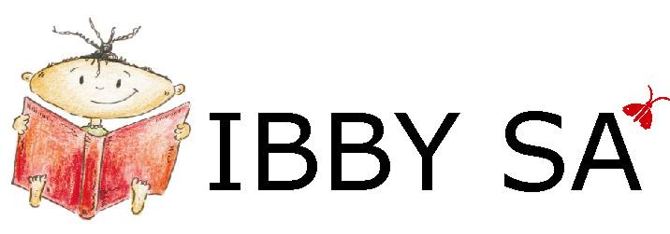
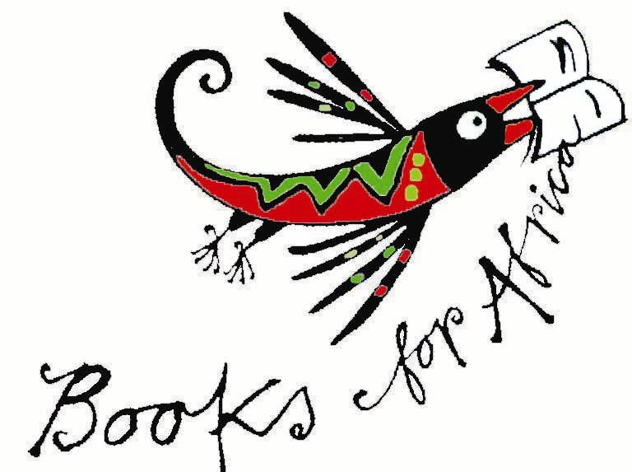
NEWSLETTER No. 58
December 2009

IBBY SA Box 847 Howard Place 7450 South Africa
email info@ibbysa.org.za
Books for Africa newsletter email booksforafrica@iafrica.com
website www.ibbysa.org.za
- IBBY SA is the South African section of IBBY.
- IBBY is the International Board on Books for Young People.
- IBBY SA’s area of interest is everything to do with South African books for children and young people.

- If you are a member of IBBY SA, you are also a member of IBBY.
- IBBY’s 2004 World Congress was hosted by IBBY SA in Cape Town.
- The 2010 World Congress will be in Santiago de Compostela, Spain

Wamkelekile! Sithemba ukuba uza kuthanda ukufunda eli phepha eli futshane eli neendaba.
Come on in, and enjoy what the newsletter has to offer by way of news and thought-provoking ideas!

Index: Exclusive Books IBBY SA Award IBBY SA Honour List Spring BookBash
Some Festive Fun QuickQuiz Competition Resensies
Holiday Greetings End

EXCLUSIVE BOOKS IBBY SA Award
Back to Index

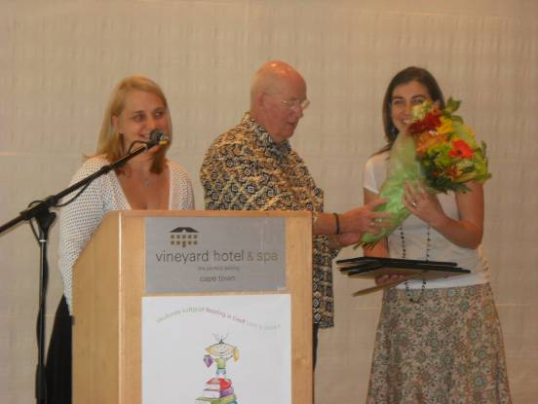
(fr. l to r.) Colleen Whitfield of Exclusive Books, Robin Malan of IBBY SA, Michelle Cooper of Tafelberg Publishers

We held back the October newsletter until we could announce the shortlist of the EB IBBY SA Award. Now we can bring you news of the winner and the awarding ceremony.

On Monday 23 November, Exclusive Books hosted a morning tea in the Summerhouse Room of The Vineyard Hotel in Newlands, Cape Town.
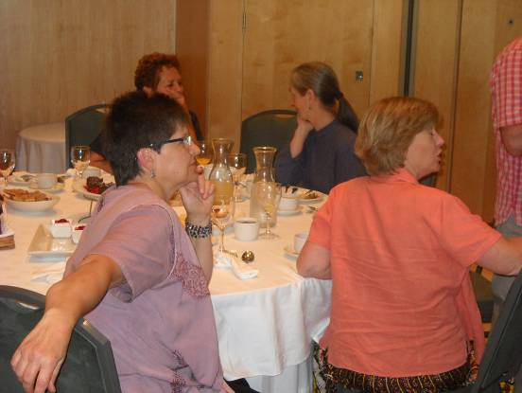
(front) Marianne Serfontein and Kathy Madlener; (in the background) Annari van der Merwe and Jude Daly

Colleen Whitfield of Exclusive Books made the following announcements:

While these three books had not made the shortlist, the Jury made Special Mention of them for their individuality:

- Nuwe Kinderverseboek Riana Scheepers en Suzette Kotzé-Myburgh (redakteurs), Teresa Williams (boekontwerper), Maja Sereda, Tamsin Hinrichsen en Dale Blankenaar (illustreeders) (Tafelberg)
- Wie is Dit? Louis Barnard (Electric Book Works)
- Drome kom altyd andersom uit André Trantraal, Nathan Trantraal and Ashley Marais (Tafelberg)

The shortlist was:
- Elsa and the little Thingamajig by Niki Daly, illustrated by Joan Rankin (Pan Macmillan)
- Happy birthday, Jamela! story and pictures by Niki Daly (Tafelberg)
- Liewe land, ’n Olifant! deur Jaco Jacobs, met illustrasies deur Maja Sereda (LAPA)
- Siyolo’s Jersey by Mari Grobler, illustrated by Elizabeth Pulles (Tafelberg)
And the winner was:
- Siyolo’s Jersey by Mari Grobler, illustrated by Elizabeth Pulles (Tafelberg)

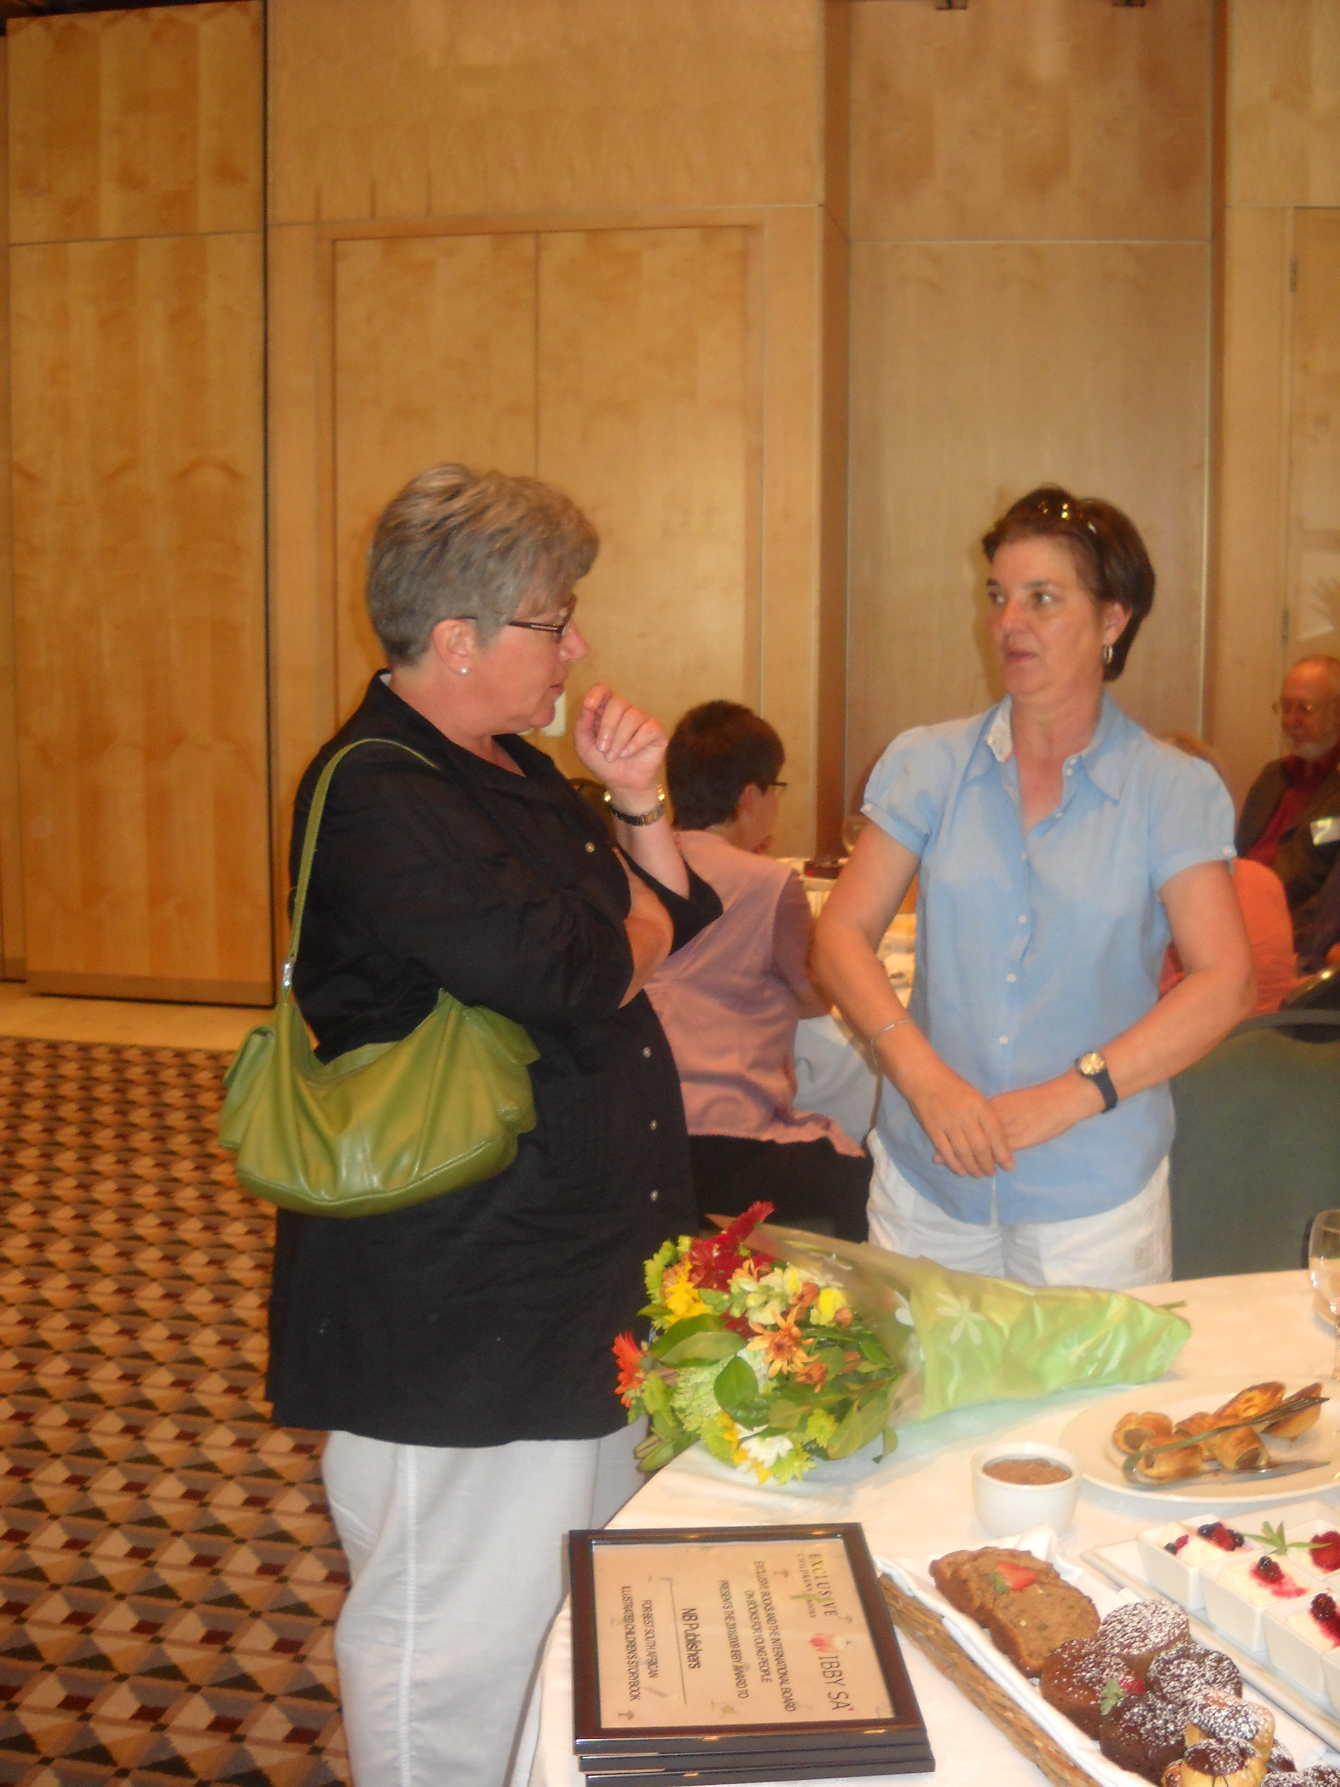

Johanna de Beer and Aldre Lategan of NB Publishers

Congratulations to Mari Grobler as writer, and to Elizabeth Pulles as illustrator. They each receive an amount of R5 000.00 from Exclusive Books. The Awards and certificates were accepted on their behalf by Michelle Cooper of Tafelberg.Present at the event were some members of the IBBY SA Exec, members of the jury, some of the shortlisted nominees and their publishers, and staff of Exclusive Books.

IBBY SA Honour List
Back to Index

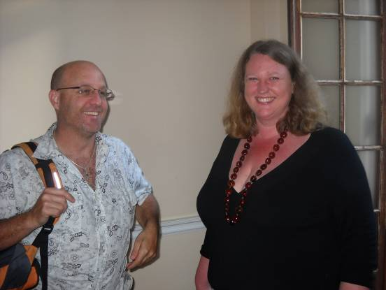
Gary Hirson and Isabel Essery at the announcement of the Honour List books

The Honour List books nominated by a jury of IBBY SA to be presented at the IBBY World Congress in Santiago de Compostela next year as books that have made a contribution to recent South African literature for children and young people were formally announced at the Spring BookBash, and certificates handed over.

This year’s Honour List books are as follows:

- Author: Afrikaans: Derick van der Walt for Lien se lankstaanskoene (Tafelberg)

- Authors: English: Dianne Case and Yvonne Hart for Katy of Sky Road (MML)

- Translation from English to Afrikaans: Jaco Jacobs for Willemien en die geel kat (from Chris Riddell’s original English Ottoline and the Yellow Cat) (LAPA)
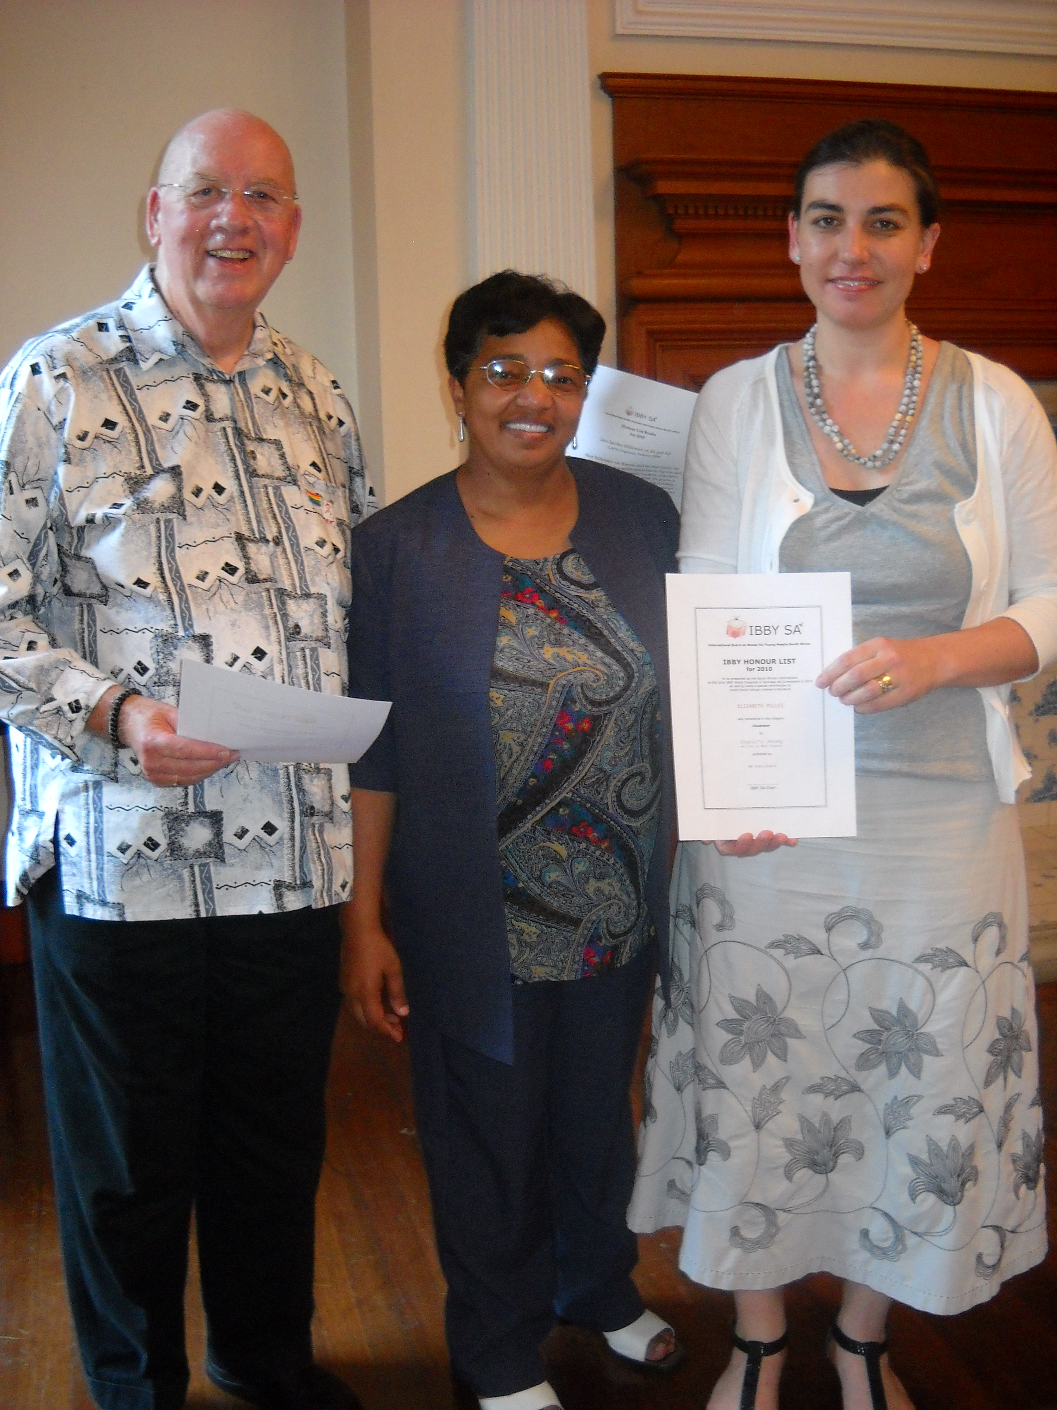
- Illustration: Elizabeth Pulles for Siyolo se trui / Siyolo’s jersey (Tafelberg)

Jean Williams, member of the IBBY Exec and Director of Biblionef SA, handed over the certificates. Dianne Case and Yvonne Hart were present to receive their certificates, and Sharon Hughes received the certificate for Maskew Miller Longman, the publisher of Katy of Sky Road.

fr. l. to r.) Robin Malan, Jean Williams and Michelle Cooper of NB Publishers

Michelle Cooper received the certificates of the two Tafelberg titles. Certificates will be posted to Jaco Jacobs and LAPA Uitgewers.

Spring BookBash
Back to Index

This took place at the Centre for the Book on Thursday 19 November 2009. About 30 people attended. Once the Honour List books had been announced, Jay Heale led a discussion on and around African myths and legends. Lively interaction took place from the floor, with Tanya Barben of the Rare Books Collection at UCT offering to take the discussions further in the future. It was an enjoyable evening, with delicious snacks provided by Yvette Couperthwaite.

Some Festive Fun / Vakansie-genot
Back to Index

Five Best-ever Books for Children or Young People

I asked a whole load of people to select their Five Best-ever Books for Children or Young People. It didn’t matter if they sent in fewer than five, or which language, or which country of origin, or which century.

I was going to work it all up into an article, but I’ve decided it’s much more fun just to read everyone’s list! For the sake of space, I have omitted all bibliographic detail. (I’ve saved that info., if anyone needs it.)
You’ll notice how cunningly some people managed to slip in a sixth or even seventh choice!

Many thanks to everyone who submitted their Five Best-evers. I didn’t thank you individually (only collectively in advance), so, now, a general, warm Thank You!

In alphabetical order by surname, here they are:

Arthur Attwell, poet, publisher:
- Asterix (any of the early ones) by René Goscinny and Albert Uderzo
- Any big, paper encyclopedia: I had a 1965 Colliers, but a Britannica would have done

- Winnie the Pooh (and House at Pooh Corner) by A A Milne
- Fantastic Mr Fox by Roald Dahl
- The Wind in the Willows by Kenneth Grahame

Lesley Beake, writer:
  - Warrior Scarlet by Rosemary Sutcliff
  - I capture the castle by Dodie Smith
  - The Nargun and the Stars by Patricia Wrightson
  - The Golden Compass (US title for Northern Lights – Ed.) by Philip Pullman
  - The curious incident of the dog in the night-time by Mark Haddon
(plus Owl Babies by Martin Waddell and Winnie the Pooh by A A Milne in younger age-groups!)

Fourie Botha, IBBY SA Exec, publisher:
- Kietsie en sy mense – a translation of a Richard Scarry book
- Where the Wild Things Are by Maurice Sendak
- Vlerkdans deur Barry Hough
- Die Sakmense deur Maretha Maartens
- The Witches by Roald Dahl

Dianne Case, writer, publisher:
  - Some of us are Leopards, Some of us are Lions by Mike Kantey
  - The Gift of Gold by Dorothy Kowen
  - As a young child, anything by Enid Blyton
  - As an older child, all the Mary Poppins series by P L Travers
  - For my grandchild, anything by Dr Seuss

M I Davids, writer, teacher:
I wonder if I can throw in my own books? Ha Ha (Why not? – Ed.)
- Danny, the Champion of the World by Roald Dahl
- Tolly, the Hero of Hanover Park by M Cassiem D’Arcy
- Bridge to Terabithia by Katherine Paterson
- 111 Colleen Court by M I Davids
- Sedick’s Kalk Bay Stories by M I Davids

Johanna de Beer, Assistant Director W Cape Library Service:
- Where the wild things are by Maurice Sendak
- Homecoming by Cynthia Voigt
- Frog and Toad are friends by Arnold Lobel,
- Little Bear by Else Holmelund Minarik
- John Brown, Rose and the Midnight Cat by Jenny Wagner

Philip de Vos, writer:
- Walker Book of Poetry for Children selected by Jack Prelutsky
- A Child’s Garden of Verses by Robert Louis Stevenson
- Peacock Pie by Walter de la Mare
- Ziezo by Annie M G Schmidt
- The Adventures of Pinocchio by Carlo Collodi

Carina Diedericks-Hugo, writer, former Chair of IBBY SA:
- Die storie van die molletjie wat wou weet wie op sy kop gedinges het – Werner Holzwarth & Wolf Erlbruch (Afrikaans)
- Het grote boek van vergeten Prinsessen – Philippe Lechermeier & Rébecca Dautremer (Dutch)
- Maasdorp-series – Stella Blakemore (Afrikaans)
- The Star of Kazan – Eva Ibbotson (English)
- Minoes – Annie M G Schmidt (Dutch)

Miemie du Plessis, publisher:
My non-South African list:
- Walk two moons by Sharon Creech
- Make lemonade by Virginia Euwer Wolff
- Out of the dust by Karen Hesse
- Kira-kira by Cynthia Kadohata
- Catherine, Called Birdy by Karen Cushman

Rheina Epstein, former librarian:
- Daddy Longlegs by Jean Webster
- Anne of Green Gables by H M Montgomery
- Little House on the Prairie by Laura Ingalls Wilder
- I am David by Anne Holm
- Homecoming by Cynthia Voigt

Isabel Essery, IBBY SA Exec, bookseller:
- The Little White Horse by Elizabeth Goudge
- Tom’s Midnight Garden by Philippa Pearce
- Five Children and It by E Nesbit
- The BFG (Big Friendly Giant) by Roald Dahl
- All the Narnia books, but especially The Horse and His Boy, by C S Lewis

Caroline Esterhuizen, Froggy Press:
- The Lion, the Witch and the Wardrobe by C S Lewis
- The Weirdstone on Brisingamen by Alan Garner
- The Twig Trilogy by Paul Stewart and Chris Riddell
- Peter and Wendy (novel of the play Peter Pan, or The Boy Who Wouldn’t Grow Up – Ed.) by J M Barrie
- The Hobbit by J R R Tolkien

Lona Gericke, librarian, IBBY SA Vice-Chair:
- I am David by Anne Holm
- Charlotte’s Web by E B White
- Skellig by David Almond
- Maniac Magee by Jerry Spinelli
- Pinocchio by Carlo Collodi

Wendy Hartmann, writer and illustrator:
I’m sending this before I change my mind again:
- Revolting Rhymes by Roald Dahl
- The Mousehole Cat by Antonia Barber
- My Cat likes to hide in Boxes by Eve Sutton
- A Kiss for Little Bear by Else Holmelund Minarik
- Heaven by Nicholas Allan
Gary Hirson, writer, publisher:
- The Magic that’s Ours by Gary Hirson
- The Power that’s Ours by Gary Hirson
- Boy and Going Solo by Roald Dahl
- The Hardy Boys (any title) by Franklin W Dixon
- Dr Seuss (any title)

Penny Hochfeld, former head of Exclusive Books children’s books:
Today’s list; tomorrow’s will be different:
- Animalia (or The Water Hole) by Graeme Base
- Not So Fast, Songololo by Niki Daly
- Number the Stars by Lois Lowry
- Stargirl by Jerry Spinelli
- Meerkat Mail by Emily Gravett (or should it be Inkheart by Cornelia Funke?)

Jaco Jacobs, writer, translator:
- To kill a mockingbird by Harper Lee
- The curious incident of the dog in the night-time by Mark Haddon
- Holes by Louis Sachar
- Love that dog by Sharon Creech
- The catcher in the rye by J D Salinger

Anna Louw, former Chair of IBBY SA:
  - Brolloks en Bittergal deur C J Langenhoven
  - Die boekie sonder naam deur C J Langenhoven
  - Die Krismiskinders deur C J Langenhoven
  - Uit my prille jeug deur A G Visser
  - Just William by Richmal Crompton

Arabella Koopman, freelance publisher:
    - Where the Wild Things Are by Maurice Sendak
    - Each Peach Pear Plum by Janet and Allan Ahlberg
    - Not now, Bernard by David McKee
    - Frida by Jonah Winter & Ana Juan

Dorothy Kowen, writer:
      - What a Gentleman by Dianne Case
      - The Cool Nguni by Maryanne Bester and Shayle Bester
      - My Dad by Niki Daly
      - Esio Trot by Roald Dahl
      - Matilda by Roald Dahl

Mary Lister, school librarian:
        - Secret Garden by Frances Hodgson Burnett
        - Secret Letters from 0 – 10 by Susie Morgenstern
        - Swallows and Amazons by Arthur Ransome
        - Winnie the Pooh by A A Milne
        - Love that Dog by Sharon Creech

Kathy Madlener, IBBY SA Exec, former school librarian:
I might give you another 5 this time next year!
- Charlotte’s Web by E B White
- Pippi Longstocking by Astrid Lindgren, just edging out Winnie the Pooh and The House at Pooh Corner by A A Milne
- The Star of Kazan by Eva Ibbotson
- The Graveyard Book by Neil Gaiman
- Beware of the Storybook Wolves by Lauren Child

Robin Malan, Chair of IBBY SA:
- Winnie the Pooh by A A Milne
- Drome kom altyd andersom uit deur André Trantraal en Nathan Trantraal en Ashley Marais
- Wie is dit? deur Louis Barnard
- UTshepo mde / Tall enough by Mhlobo Jadezweni illustrated by Hannah Morris
- Remembering Mommy by Carole Bloch, Boyce Boulix Mgcina, Rafeekah Patel, Juliana Seleti, Ethel Sithole, illustrations by Robert Hichens

Gcina Mhlophe, writer, storyteller:
  - Iphupho Lika Nkulunkulu / God’s Dream by Desmond Tutu and Douglas Carlton Abrams, illustrations by Leuyen Pham

Beverley Naidoo, writer:
Tomorrow they might be different:
- The Diary of Anne Frank by Anne Frank
- Roll of Thunder, Hear My Cry by Mildred D Taylor
- The Tales of Uncle Remus: The Adventures of Brer Rabbit as told by Julius Lester & illustrated by Jerry Pinkey (with thanks to generations of African storytellers)
- The Butterfly Lion by Michael Morpurgo, illustrated by Christian Birmingham
- Mafia and the aeroplane by Max Sed, illustrations by Sophie Peters
- Coram Boy by Jamila Gavin

Sally-Ann Partridge, writer:
- The Nancy Drew series by Carolyn Keene
- Harry Potter series by J K Rowling
- The Enchanted Wood by Enid Blyton
- Fuse by S A Partridge
- Twilight by Stephanie Meyer

Inge Paulsen, IBBY SA Exec:
- Guess How Much I Love You by Sam McBratney
- Hop on Pop and Green Eggs and Ham by Dr Seuss
- Titch by Pat Hutchins
- Where the Wild Things Are by Maurice Sendak
- Chicka Chicka Boom Boom by Bill Martin Jr and John Archambault

Vinesh Rajpaul, IBBY SA newsletter book reviewer:
- Alice’s Adventures in Wonderland by Lewis Carroll
- The Lorax by Dr Seuss
- Peter and Wendy by J M Barrie
- The Wind in the Willows by Kenneth Grahame
- His Dark Materials trilogy by Philip Pullman

Reviva Schermbrucker, writer:
- Huckleberry Finn by Mark Twain
- Edward Lear’s nonsense poetry
- Mother Goose
- The Cat in the Hat by Dr Seuss (actually, all his books!)
- Winnie the Pooh by A A Milne

Marianne Serfontein, book selector at Edulis:
- Thank you, Mr Falker by Patricia Polacco
- The tale of Despereaux by Kate DiCamillo
- Granny Torrelli makes soup by Sharon Creech
- The invention of Hugo Cabret by Brian Selznick
- The Water Hole by Graeme Base (and/or Willy’s pictures by Anthony Browne)

Mooniq Shaikjee, IBBY SA newsletter book reviewer:
- The Hobbit by J R R Tolkien
- Charlie and the Chocolate Factory by Roald Dahl
- The Amazing Maurice and His Educated Rodents by Terry Pratchett
- The Hitch-Hiker’s Guide to the Galaxy by Douglas Adams
- Northern Lights by Philip Pullman

Peter Slingsby, writer:
- I am David by Anne Holm, translated from the Danish by L W Kingsland
- Little House on the Prairie by Laura Ingalls Wilder
- Thomas the Tank Engine by W V Awdry
- Jonker Afrikaner by Jenny Seed

Dianne Stewart, writer:
- The Lion, the Witch and the Wardrobe by C S Lewis
- James and the Giant Peach by Roald Dahl
- The Cricket in Times Square by George Selden
- The Princess and the Pea by Hans Christian Anderson
- Stuart Little by E B White

André Trantraal, writer and cartoonist:
- Angela and the Baby Jesus by Frank McCourt
- The Curious Incident of the Dog in the Night-time by Mark Haddon
- The His Dark Materials trilogy by Philip Pullman
- In The Night Kitchen by Maurice Sendak
- The Just William books by Richmal Crompton

Nathan Trantraal, writer and cartoonist:
- Tintin in Tibet by Hergé
- Where the Wild Things Are by Maurice Sendak
- The Dreamfighter and other creation tales by Ted Hughes
- The Man by Raymond Briggs
- The Daydreamer by Ian McEwan

Annari van der Merwe, former publisher, first Chair of SACBF (precursor of IBBY SA):
- A Girl of the Limberlost by Gene Stratton-Porter
- Anne of Green Gables by Lucy Maud Montgomery
- Selina, Moestassie en die kat Toeterjat by Suzi Bohdal, translated by Linda Rode, original German title Pumpernickel und die Katze Flora
- Ai, hoe mooi is dit in Panama by Janosch, translated by Leon Rousseau, original German title Oh, wie schön ist Panama
- Frederick by Leo Lionni, translated by Leo van der Westhuijzen

Jean Williams, Director of Biblionef SA:
- Handa’s Surprise by Eileen Brown
- Sam’s Smile by Ian Lusted
- The Red Dress by Dux van der Walt
- Brenda has a dragon in her blood by Hylte Vink
- God’s Dream by Desmond Tutu

QuickQuiz Competition
Back to Index

The previous newsletter’s question asked where and when the IBBY World Congress was that took place in Cape Town. Here’s Helen Brain’s right answer, which came back quick as a flash: Answer: IBBY conference took place in the Baxter Theatre Cape Town, in September 2004.
Well done, Helen. An IBBY book is on its way to you.

This month, because it’s holidays and you have so much leisure time, you
have to work for your prize. A four-part question: Tell us (a) which book/s feature/s most often in the 5 Best-evers above, and (b) how many times it/they appear/s; (c) which author/s appear/s most often, and (d) how many times?

Please email your response to
booksforafrica@iafrica.com .

Remember to give your postal address, in case you win.

Resensies

Back to Index

Vir die volle resensies van die volgende boeke, gaan asb. na ons webwerf: www.ibbysa.org.za

Aspris-krokkedis deur Theresa van Baalen, met illustrasies deur Joan Rankin
(LAPA, 2009) – Lona Gericke
Flipom deur Francois Bloemhof (LAPA, 2009) – Lona Gericke
Helouise die swart tobie deur Maritha Snyman, met illustrasies deur Samantha van Riet (LAPA, 2009) – Lona Gericke
Kondensmelk deur Christien Neser (LAPA, 2009) – Lona Gericke
Los ons uit! deur Martie Preller, met illustrasies deur Andries en Erica Maritz (LAPA, 2009) – Lona Gericke
Middernagfees deur Jaco Jacobs, met illustrasies deur Chris Venter (LAPA, 2009) – Lona Gericke
Mooiste dierestories, Die deur Wendy Maartens, met illustrasies deur Natalie en Tamsin Hinrichsen (LAPA, 2009) – Lona Gericke
Spoke, speurders en straatkafees deur Nerine Ahlers en Alet Steenkamp (LAPA, 2009) – Lona Gericke

Holiday Greetings
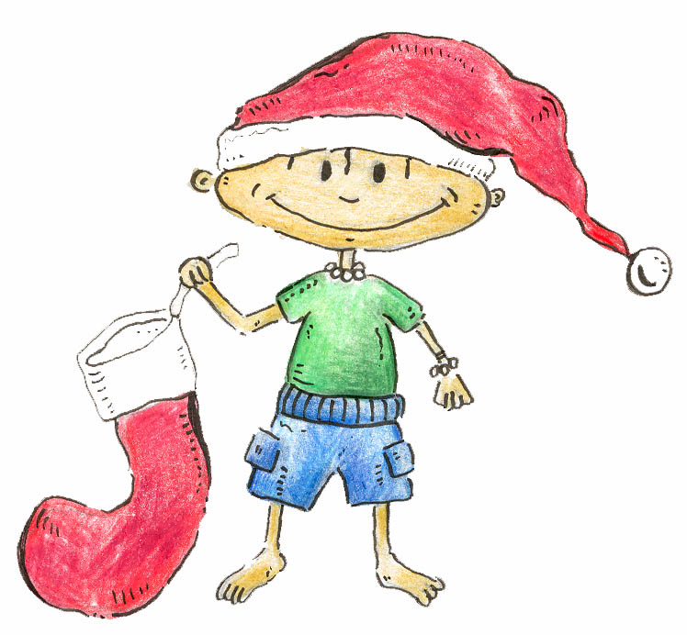
Back to Index

Thanks from the IBBY SA Exec for your support throughout the year. It’s been great. We wish you all a happy, restful, healthy holiday season. Enjoy it all, and don’t forget to set aside some time to do some reading! If your holiday season involves giving presents, give a book! If you have small children in a kilometre radius of you, read them a story!

We look forward to your support again in 2010.

End
Back to Index
Text: Robin Malan
Layout & Design: Inge Paulsen

