Los libros violetas
PROJECT REPORT

By:
Fundación Leer/IBBY Costa Rica

Introduction

We are beings of language and beings of stories, charged with a restorative value. The word and orality in these moments of uncertainty will be difficult in elements to face this difficulty in family and community and with the hope of getting ahead as a country. This abrupt crisis that has surprised us entails a loss of sense of daily life and forces us to change the dynamics of our day to day. However, in the midst of so much uncertainty throughout history, we have learned how humanity has managed to overcome every difficulty in community, in communion with solidarity.

In response to the contingencies and guidelines issued by the central government to counteract the spread of COVID-19 in Costa Rica, below, we present a proposal to adjust the project "Los libros violetas", taking into account that in its original version a significant percentage of the activities were planned to conduct face-to-face workshops and visits in educational centers; The activities were transferred to virtual environments and thus contribute to strategies of social isolation.

Overall objective:
- Promote gender equity in 30 Costa Rican public schools, through children's literature, in order to generate education relevant to the characteristics of girls and boys.

Activities:
- Promote a methodology, through children's books, that encompasses gender equity, thus generating coexistence and complementarity in the classroom.
- Reflect on the need to include the gender focus in the student orientation activities of I and II cycles, in order to promote personal and professional life projects free of sexism and discrimination.
- Prepare a guide that offers an updated list of youth books related to gender equity.
- Recognize the school as one of the main areas of reproduction of sexism and expose its potential to develop strategies that favor the change in unequal relations between the sexes.

Changes made due to COVID-19:
- The face-to-face workshops were scheduled through Google Met and Google Classroom, since the organization does not have a platform for its educational offer. As a result, a company was hired to improve the website and link an educational platform to the web.
- The material was sent by post from Costa Rica to the participating teachers.
- Enrollment was extended to the course, the proposal was intended to benefit 30 teachers, but thanks to virtually, enrollment was doubled to 60 beneficiaries.

- Evidence: final products

- Work guide: Introduction “Los libros violetas: análisis de la literatura infantil a partir de la teoría de género”.

Reading sheet for “Mo”.

Reading sheet for “La Danta en Pasarela”.

Reading sheet for “El árbol solito”.

- Reading sheet for “Dora la Lora y Chico el perico”.

- Reading sheet for “Raúl pintando de azul”.

- Reading sheet for “Papá es un campeón”.

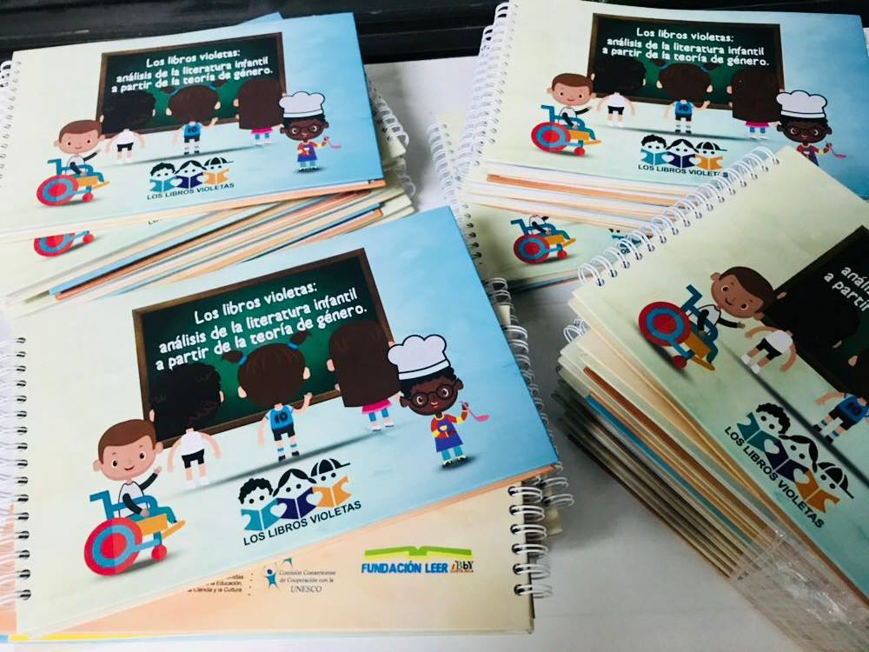

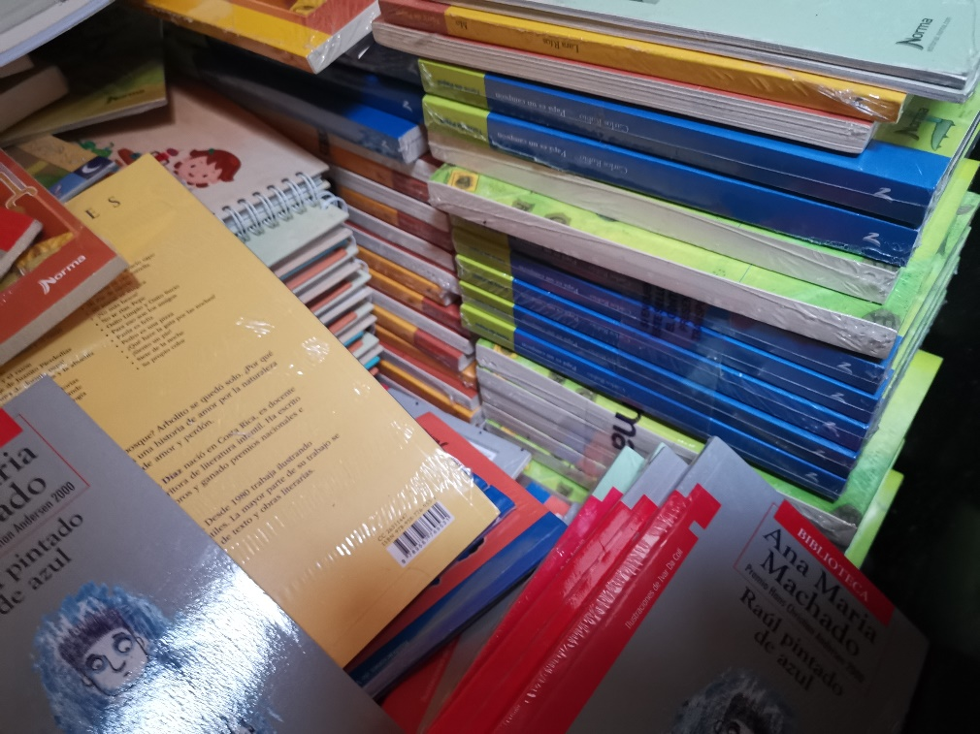
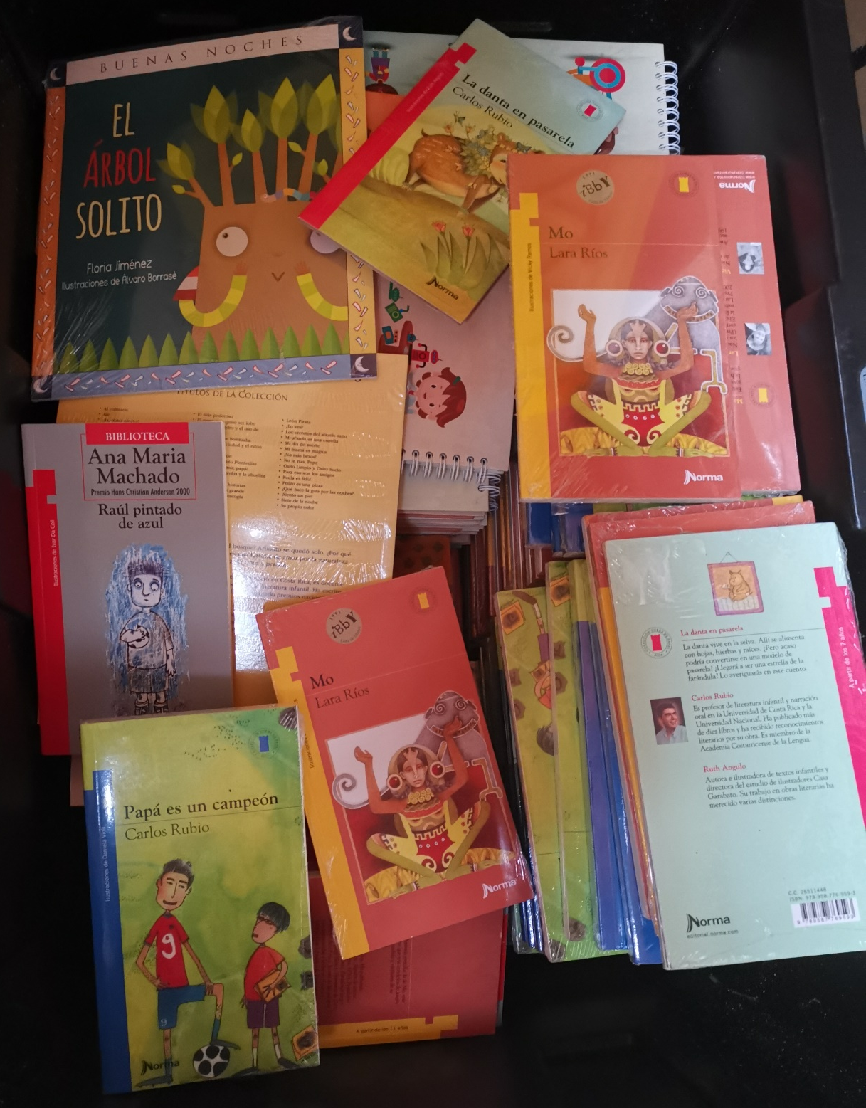

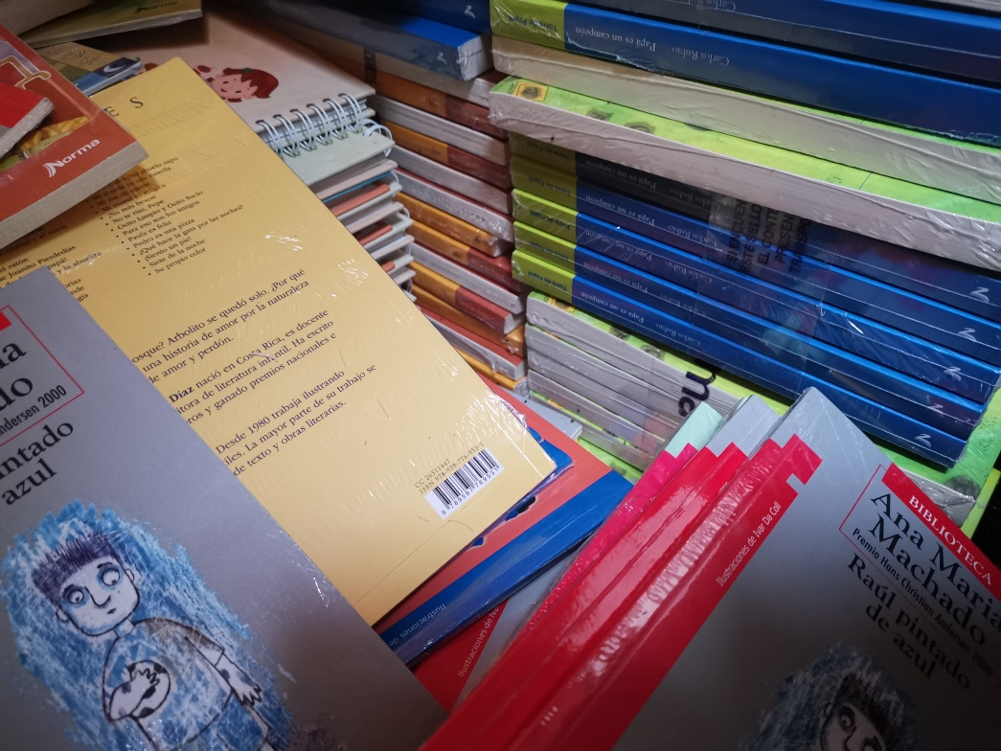

IMPACT

60 public schools
+ 27.000 benefited students

+ 160 Benefit teachers

Budget

Description | Amount ₡ | Amount $ | # Bill | Date | # annexed | Observations
Guide design | ₡ 1.240.000 | $ 2.573 | 00100001010000000204 | 28/02/2020 | # 1 | Elaboration of content and graphic design.
Buying books | ₡1 170 000,00 | $ 2.007 | 00100001010000004455 | 12/02/2020 | # 2 | They were sent through mails from Costa Rica
Supplies: workshop materials | ₡796.742,66 | $ 1.366 | 00100001010000000033 | 21/02/2020 | # 3 | They were purchased before the pandemic by COVID-19
Supplies: sound materials for the development of the face-to-face workshops | ₡ 112.992,80 | $ 193 | 00100001010000041846 | 15/02/2020 | #4 | They were purchased before the pandemic by COVID-19
Supplies: sound materials for the development of the face-to-face workshops | ₡ 81.770 | $ 140 | 00800011010000004648 | 18/02/2020 | # 5 | They were purchased before the pandemic by COVID-19
Sending material through post mail | ₡405.237 | $ 695 | 0010062701000033991 | 16/04/2020 | #6
Total | ₡ 3.806.743 | $6.974
Remainder: $ 526 will be used to pay for the programming of the virtual space

Exchange rate: $ 1 = ₡ 583.09 colones

Pending Products:

- A virtual space through the Moodle platform for upcoming trainings, linked to the organization's page.
- Final report

